ROBÔ ARTICULADO RRR – CINEMÁTICA DIRETA
1. Tabela DH
A tabela de Denavit-Hartenberg utilizada para o robô RRR é:
Junta (i) | dᵢ | θᵢ | aᵢ | αᵢ
1 | d₁ | θ₁ | 0 | −90°
2 | 0 | θ₂ | a₂ | 0°
3 | 0 | θ₃ | a₃ | 0°
2.TRANSFORMAÇÕES
⁰T₁
⁰T₁ =
⎡ cos(θ₁) 0 −sen(θ₁) 0 ⎤
⎢ sen(θ₁) 0 cos(θ₁) 0 ⎥
⎢ 0 −1 0 d₁⎥
⎣ 0 0 0 1 ⎦
¹T₂
¹T₂ =
⎡ cos(θ₂) −sen(θ₂) 0 a₂cos(θ₂) ⎤
⎢ sen(θ₂) cos(θ₂) 0 a₂sen(θ₂) ⎥
⎢ 0 0 1 0 ⎥
⎣ 0 0 0 1 ⎦
²T₃
²T₃ =
⎡ cos(θ₃) −sen(θ₃) 0 a₃cos(θ₃) ⎤
⎢ sen(θ₃) cos(θ₃) 0 a₃sen(θ₃) ⎥
⎢ 0 0 1 0 ⎥
⎣ 0 0 0 1 ⎦
⁰T₃ = ⁰T₁ · ¹T₂ · ²T₃
⁰T₃ = ⁰T₁ · ¹T₂ · ²T₃
⁰T₃ =
⎡ c₁c₂₃ −c₁s₂₃ −s₁ c₁[a₂c₂ + a₃c₂₃] ⎤
⎢ s₁c₂₃ −s₁s₂₃ c₁ s₁[a₂c₂ + a₃c₂₃] ⎥
⎢ −s₂₃ −c₂₃ 0 d₁ − a₂s₂ − a₃s₂₃ ⎥
⎣ 0 0 0 1 ⎦
onde c₁ = cos(θ₁), s₁ = sen(θ₁), c₂ = cos(θ₂), s₂ = sen(θ₂), c₂₃ = cos(θ₂ + θ₃) e s₂₃ = sen(θ₂ + θ₃).
3. Uso do OCTAVE (código simbólico)
clear all;
close all;
clc;

% ============================================================
% Pacote simbólico
% ============================================================
pkg load symbolic

% ============================================================
% Variáveis simbólicas
% ============================================================
syms d th a alpha real
syms d1 th1 th2 th3 a2 a3 real
deg2rad_sym = @(d) sym(d) * sym(pi) / sym(180);
pi2 = sym(pi)/2;
one = sym(1);
zero = sym(0);

% ============================================================
% Matriz de Denavit-Hartenberg
% ============================================================
A_DH = [ cos(th) -sin(th)*cos(alpha) sin(th)*sin(alpha) a*cos(th)
sin(th) cos(th)*cos(alpha) -cos(th)*sin(alpha) a*sin(th)
zero sin(alpha) cos(alpha) d
zero zero zero one ];

% ============================================================
% Cadeia de transformações do robô RRR (100% simbólica)
% ============================================================
% --------- Frame {0} ---------
F0 = sym(eye(4));
% --------- Frame {1} ---------
%i1 d = d1, theta = th1 a = 0, alpha = -90 = -pi/2
A1 = subs(A_DH, [d th a alpha], [d1 th1 zero -pi2]);
F1 = F0 * A1;

% --------- Frame {2} ---------
%i2 d = 0, theta = th2 a = a2, alpha = 0
A2 = subs(A_DH, [d th a alpha], [zero th2 a2 zero]);
F2 = F1 * A2;

% --------- Frame {3} ---------
%i3 d = 0, theta = th3 a = a3, alpha = 0
A3 = subs(A_DH, [d th a alpha], [zero th3 a3 zero]);
F3 = F2 * A3;

% ============================================================
% Exibição das transformações
% ============================================================
pretty(A1)
pretty(A2)
pretty(A3)

A03 = simplify(F3);
pretty(A03)

% ============================================================
% Parâmetros numéricos
% ============================================================
t1s = deg2rad_sym(0);
t2s = deg2rad_sym(-30);
t3s = deg2rad_sym(60);
d1s = sym(3);
a2s = sym(3);
a3s = sym(3);

A03_num = subs(A03,[th1 th2 th3 d1 a2 a3],[t1s t2s t3s d1s a2s a3s]);
A03_num = double(vpa(A03_num, 12));

disp('A03 numerica:')
disp(A03_num)

% --------- Substituições -> vpa -> double ---------
F0 = eye(4);
F1 = double(vpa(subs(F1, [th1 d1], [t1s d1s]), 12));
F2 = double(vpa(subs(F2, [th1 th2 d1 a2], [t1s t2s d1s a2s]), 12));
F3 = double(vpa(subs(F3, [th1 th2 th3 d1 a2 a3],[t1s t2s t3s d1s a2s a3s]), 12))

% ==== Plot ====
figure(1); clf;
axis equal; grid on; view(3);
xlabel('x'); ylabel('y'); zlabel('z'); hold on;
esc = 0.7;
mark = 1;
% ---------- Frame {0} ----------
plot3(F0(1,4), F0(2,4), F0(3,4), 'om', 'linewidth', 2, 'markersize', mark);
plot3([F0(1,4) F0(1,4)+esc*F0(1,1)], [F0(2,4) F0(2,4)+esc*F0(2,1)], [F0(3,4) F0(3,4)+esc*F0(3,1)], 'b','linewidth', 2);
text( F0(1,4)+esc*F0(1,1), F0(2,4)+esc*F0(2,1), F0(3,4)+esc*F0(3,1), 'x_{\{0\}}');
plot3([F0(1,4) F0(1,4)+esc*F0(1,2)], [F0(2,4) F0(2,4)+esc*F0(2,2)], [F0(3,4) F0(3,4)+esc*F0(3,2)], 'g','linewidth', 2);
text( F0(1,4)+esc*F0(1,2), F0(2,4)+esc*F0(2,2), F0(3,4)+esc*F0(3,2), 'y_{\{0\}}');
plot3([F0(1,4) F0(1,4)+esc*F0(1,3)], [F0(2,4) F0(2,4)+esc*F0(2,3)], [F0(3,4) F0(3,4)+esc*F0(3,3)], 'r','linewidth', 2);
text( F0(1,4)+esc*F0(1,3), F0(2,4)+esc*F0(2,3), F0(3,4)+esc*F0(3,3), 'z_{\{0\}}');
plot3([F0(1,4) F1(1,4)], [F0(2,4) F1(2,4)], [F0(3,4) F1(3,4)], 'k');
% ---------- Frame {1} ----------
plot3(F1(1,4), F1(2,4), F1(3,4), 'om','linewidth',2,'markersize',mark);
text(F1(1,4), F1(2,4), F1(3,4)-0.2, '\{1\}')
plot3([F1(1,4) F1(1,4)+esc*F1(1,1)], [F1(2,4) F1(2,4)+esc*F1(2,1)], [F1(3,4) F1(3,4)+esc*F1(3,1)],'b','linewidth',2)
text(F1(1,4)+esc*F1(1,1), F1(2,4)+esc*F1(2,1), F1(3,4)+esc*F1(3,1), 'x_{\{1\}}')
plot3([F1(1,4) F1(1,4)+esc*F1(1,2)], [F1(2,4) F1(2,4)+esc*F1(2,2)], [F1(3,4) F1(3,4)+esc*F1(3,2)],'g','linewidth',2)
text(F1(1,4)+esc*F1(1,2), F1(2,4)+esc*F1(2,2), F1(3,4)+esc*F1(3,2), 'y_{\{1\}}')
plot3([F1(1,4) F1(1,4)+esc*F1(1,3)], [F1(2,4) F1(2,4)+esc*F1(2,3)], [F1(3,4) F1(3,4)+esc*F1(3,3)],'r','linewidth',2)
text(F1(1,4)+esc*F1(1,3), F1(2,4)+esc*F1(2,3), F1(3,4)+esc*F1(3,3), 'z_{\{1\}}')
plot3([F1(1,4) F2(1,4)], [F1(2,4) F2(2,4)], [F1(3,4) F2(3,4)], 'k')
% ---------- Frame {2} ----------
plot3(F2(1,4), F2(2,4), F2(3,4), 'om','linewidth',2,'markersize',mark);
text(F2(1,4), F2(2,4), F2(3,4)-0.2, '\{2\}')
plot3([F2(1,4) F2(1,4)+esc*F2(1,1)], [F2(2,4) F2(2,4)+esc*F2(2,1)], [F2(3,4) F2(3,4)+esc*F2(3,1)],'b','linewidth',2)
text(F2(1,4)+esc*F2(1,1), F2(2,4)+esc*F2(2,1), F2(3,4)+esc*F2(3,1), 'x_{\{2\}}')
plot3([F2(1,4) F2(1,4)+esc*F2(1,2)], [F2(2,4) F2(2,4)+esc*F2(2,2)], [F2(3,4) F2(3,4)+esc*F2(3,2)],'g','linewidth',2)
text(F2(1,4)+esc*F2(1,2), F2(2,4)+esc*F2(2,2), F2(3,4)+esc*F2(3,2), 'y_{\{2\}}')
plot3([F2(1,4) F2(1,4)+esc*F2(1,3)], [F2(2,4) F2(2,4)+esc*F2(2,3)], [F2(3,4) F2(3,4)+esc*F2(3,3)],'r','linewidth',2)
text(F2(1,4)+esc*F2(1,3), F2(2,4)+esc*F2(2,3), F2(3,4)+esc*F2(3,3), 'z_{\{2\}}')
plot3([F2(1,4) F3(1,4)], [F2(2,4) F3(2,4)], [F2(3,4) F3(3,4)], 'k')
% ---------- Frame {3} ----------
plot3(F3(1,4), F3(2,4), F3(3,4), 'om','linewidth',2,'markersize',mark);
text(F3(1,4), F3(2,4), F3(3,4)-0.2, '\{3\}')
plot3([F3(1,4) F3(1,4)+esc*F3(1,1)], [F3(2,4) F3(2,4)+esc*F3(2,1)], [F3(3,4) F3(3,4)+esc*F3(3,1)],'b','linewidth',2)
text(F3(1,4)+esc*F3(1,1), F3(2,4)+esc*F3(2,1), F3(3,4)+esc*F3(3,1), 'x_{\{3\}}')
plot3([F3(1,4) F3(1,4)+esc*F3(1,2)], [F3(2,4) F3(2,4)+esc*F3(2,2)], [F3(3,4) F3(3,4)+esc*F3(3,2)],'g','linewidth',2)
text(F3(1,4)+esc*F3(1,2), F3(2,4)+esc*F3(2,2), F3(3,4)+esc*F3(3,2), 'y_{\{3\}}')
plot3([F3(1,4) F3(1,4)+esc*F3(1,3)], [F3(2,4) F3(2,4)+esc*F3(2,3)], [F3(3,4) F3(3,4)+esc*F3(3,3)],'r','linewidth',2)
text(F3(1,4)+esc*F3(1,3), F3(2,4)+esc*F3(2,3), F3(3,4)+esc*F3(3,3), 'z_{\{3\}}')

4.Simulações e Plots
t1s = deg2rad_sym(0); d1s = sym(3);
t2s = deg2rad_sym(-30); a2s = sym(3);
t3s = deg2rad_sym(60); a2s = sym(3);
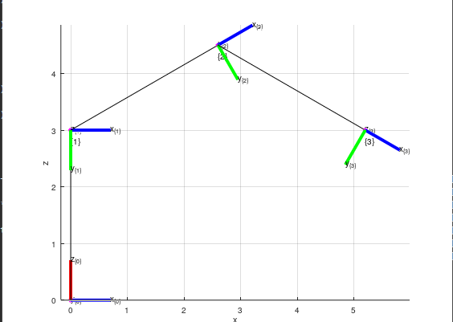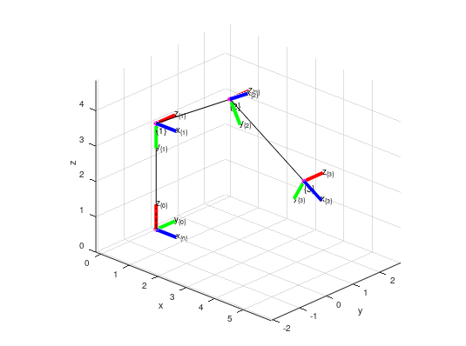
t1s = deg2rad_sym(0); d1s = sym(5);
t2s = deg2rad_sym(0); a2s = sym(4);
t3s = deg2rad_sym(0); a2s = sym(3);
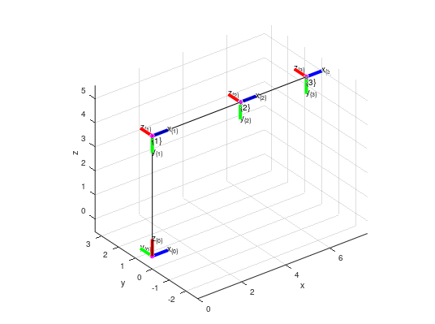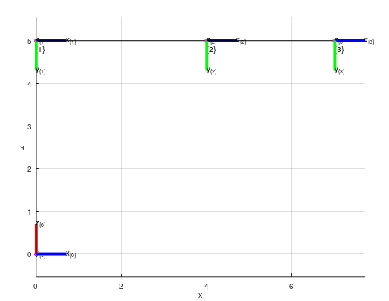

5. Observação
Pela regra da mão direita, considerando a orientação dos referenciais adotada, o ângulo entre z₀ e z₁ é α₁ = −90°.

6. Refências
FERREIRA, D. d. A. Lab. – Revisão de Conceitos. Campinas, SP, 2026. Material didático
da disciplina Robótica Computacional. Notas de aula e slide.
FERREIRA, D. d. A. Octave Atividade 01. Campinas, SP, 2026. Material didático da disciplina
Robótica de Computacional.
FERREIRA, D. d. A. Aula 008 — DH PT02. Campinas, SP, 2026. Material didático da disciplina
Robótica Computacional. Notas de aula e slide.
THE OCTAVE PROJECT DEVELOPERS. GNU Octave Documentation, Version 11.1.0. [S.l.],
2026. Acessado em: 19 set. 2026. Disponível em: <https://docs.octave.org/v11.1.0/>.

